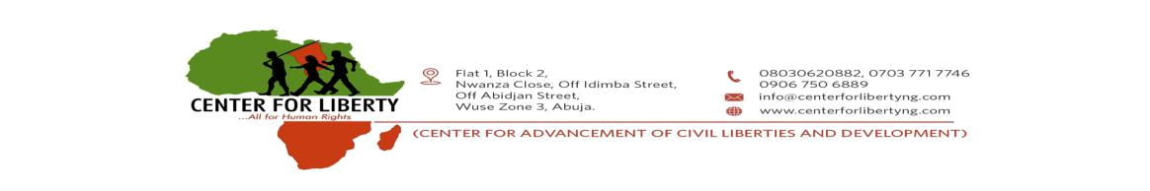

8th July, 2020

Dr. Ahmed Ibrahim Lawan

President of the Senate & Chairman, National Assembly

Federal Republic of Nigeria

Three Armed Zone

Abuja

LETTER TO THE SENATE: Entreating The National Assembly To Halt Its Annual Recess

The Center for Advancement of Civil Liberties and Development, also known as the Center for Liberty (CFL), is a non-governmental organization that is presently focused on Electoral Reforms, among other core issues bordering on democratic governance and social change in Nigeria.

We are encouraged to write you at this time, having followed the Upper Chamber’s recent successes and consistent efforts at reforms in different sectors; particularly with the recent passage into law of the Police Act (Repeal and Re-enactment) Bill, 2020 (SB. 181); as well as the recent passage of the anti-sexual harassment Bill, formally described as ‘A Bill for an Act to prevent, prohibit and redress Sexual Harassment of students in tertiary educational institutions and for matters concerned therewith, 2019.’ We believe that these recent efforts will contribute largely to steering aright, the conscience of our beloved nation.

In times like this, with over 29, 0000 COVID-19 cases, nearly 700 deaths recorded in Nigeria, and with the attendant effects on the economy and governance, we are compelled to necessarily seek the leadership of the Nigerian Senate. And given the fact that the Nigerian Senate is working tirelessly to make reforms its priority, we are even more compelled to draw the hallowed chamber’s attention to the urgency of Electoral Reforms in the country. And one of the ways the hallowed chamber can help the country in this regard is to consider the swift passage of the Electoral Reform Bill formally known as ‘A Bill for an Act to Amend the Electoral Act (No. 6) 2010 and Other Related Matters, 2019.’

According to the Sponsor of the Bill; Senator Ovie-Omo Agege, electoral reforms is an “extremely important national assignment,” and the Bill in focus is a sequel to various apex court verdicts which, in the words of the Deputy Senate President “were directly tasking the National Assembly to make vital electoral reforms in this country by amending or even overhauling the extant Electoral Act.” Although it can be said that Nigeria has missed a golden opportunity to test-run the practicability of the amendments in the proposed Electoral Bill in the forthcoming Edo and Ondo States governorship elections,
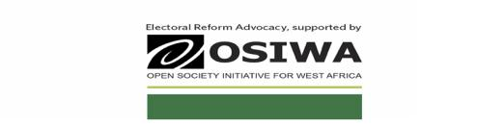

CFL is convinced that the passage of the proposed Bill can be achieved this year (2020), should the Senate be willing to dedicate more time and zeal to the process.

Most instructive is the fact that Electoral Reforms now represent a major Citizens Charter of Demand to the National Assembly for the year 2020. Ten years after Electoral Act 2010 was passed, Nigerians are eager to have Electoral Act 2020 (Repeal and Re-enactment). We dare say that there is no better legacy on Electoral Reforms, than to give Nigerians a brand new Act this year. It is now the most sought-after legislation in the country by the generality of the people. And, with the modest effort already made by the 8th Session of the National Assembly on Electoral Reforms, in which the current principal officers were major actors, the people are of the firm opinion that Electoral Act 2020 should be a walk in the park for the 9th. This is coupled with the fact that President Muhammadu Buhari had expressed his willingness to sign the last amended version forwarded to him, only if the “Electoral Act will come into effect commencing after the 2019 General Elections.” An indication that the we almost had the bill signed, except that the current idea of Repeal and Re-enactment is a welcome development.

We are, therefore, compelled by the reasons above to, in the best interest of Nigeria’s democracy and her overall well-being, earnestly entreat the Nigerian Senate to halt its plans to go on its annual recess this year until the Electoral Reform Bill is passed. We further acknowledge that this would likely cause inconveniences to distinguished lawmakers, but as has been evident in this trying time, the Nigerian people need the effervescent direction of its leadership strata at all levels, and in this case, Electoral Reform will guide the country to her destined path of Credible Elections and Electoral Justice, just as it will cast the name of the members of the Ninth Hallowed Chamber in gold.

In addition, the passage of this bill will be a heavy-lifting of burden on the judiciary, which has been calling for electoral reforms and amendments to some laws governing our elections. Nigerians will be most delighted to have Electoral Act 2020; and so also will CFL and other partners implementing a people-driven Electoral Reform Advocacy (ERA) with the support of the Open Society Initiative for west Africa (OSIWA).

Please accept the assurances of our highest esteem.

Signed

Ariyo-Dare Atoye

Co-Convener

Adebayo Raphael

Co-Convener

